MANA's 2021 CRNA Spotlight
Kimberly Bowens

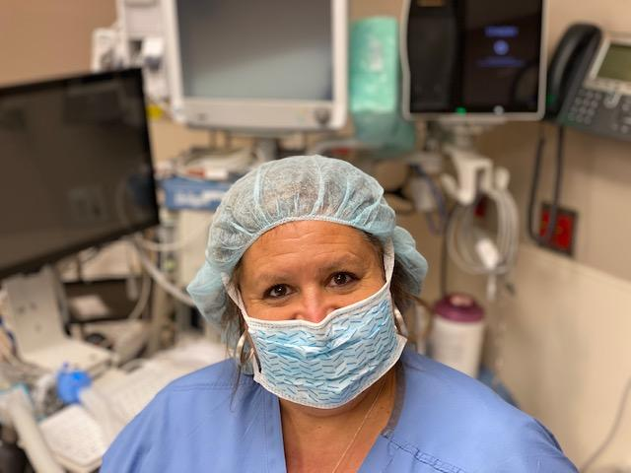
Hometown: Ashland, MA
Facility: Ambulatory Surgery Center at MGH Waltham
On Being a CRNA:
I shadowed a CRNA when I was fourteen years old. I was so awestruck by the concept of bringing a person from pre-op, through a surgical procedure, to waking up in the recovery room. To this day I still take a delight in accomplishing that very task.
Kim's COVID Experience:
When our surgery center was shutdown, I volunteered to work at the COVID testing center at our main campus. After several weeks of working in the testing center, I was deployed to work at Boston Hope (a temporary COVID field hospital). My role was working as a responding clinician caring for inpatients, conducting admissions and discharging patients. I embraced the opportunity to utilize skills that I often do not use as a CRNA. I worked with a combination of primary care providers which included pediatricians, school nurses and military personnel. They appreciated having anesthesia providers on campus to be available for patients who needed blood drawn or to manage a code when needed. I did have trepidation about working with COVID patients. I put my faith in my protective equipment and hand washing, with the belief that I was not meant to contract and succumb to COVID.
Kim is #CRNAProud when:
the most anxious patients wake up “sparkly” and grateful the procedure is over.
I see the wheels working behind the eyes of a young student nurse anesthetist. It is rewarding to work with a student and witness the transformation from a critical care nurse to a nurse anesthetist.
Fun fact about Kim:
I was interviewed on Good Morning America about being bi-racial.
I sailed on a traditional American sailboat at the America’s Cup in New Zealand.

